# Dockerized FastAPI Application Setup

***Step1*:** Fork and Clone the given Repository

CMD: gitclone<https://github.com/RohitPatil18/docker-fastapi-test>

***Step2*:** Create a Dockerfile and docker-compose.yml file

CMD: vi Dockerfile

# Using the official Python Image

FROM python:3.9

# Set the working directory in the container

WORKDIR /app

# Copy the requirements.txt file and install the Python dependencies

COPY requirements.txt ./app

RUN pip install --no-cache-dir -r requirements.txt

# Copy the application files to the container

COPY . /app

# Expose the necessary port

EXPOSE 8000

# Define the command to run the application

CMD ["uvicorn", "main:app", "--host", "0.0.0.0", "--port", "8000"]

CMD: vi docker-compose.yml version: "3.9" services: core_api:

build: .

container_name: "docker-fastapi-test"

ports:

* "8000:8000" volumes:
* ./:/app

***Step3*:** Create a Container by using above Docker Files

CMD: sudo docker-compose build

sudo docker-compose up

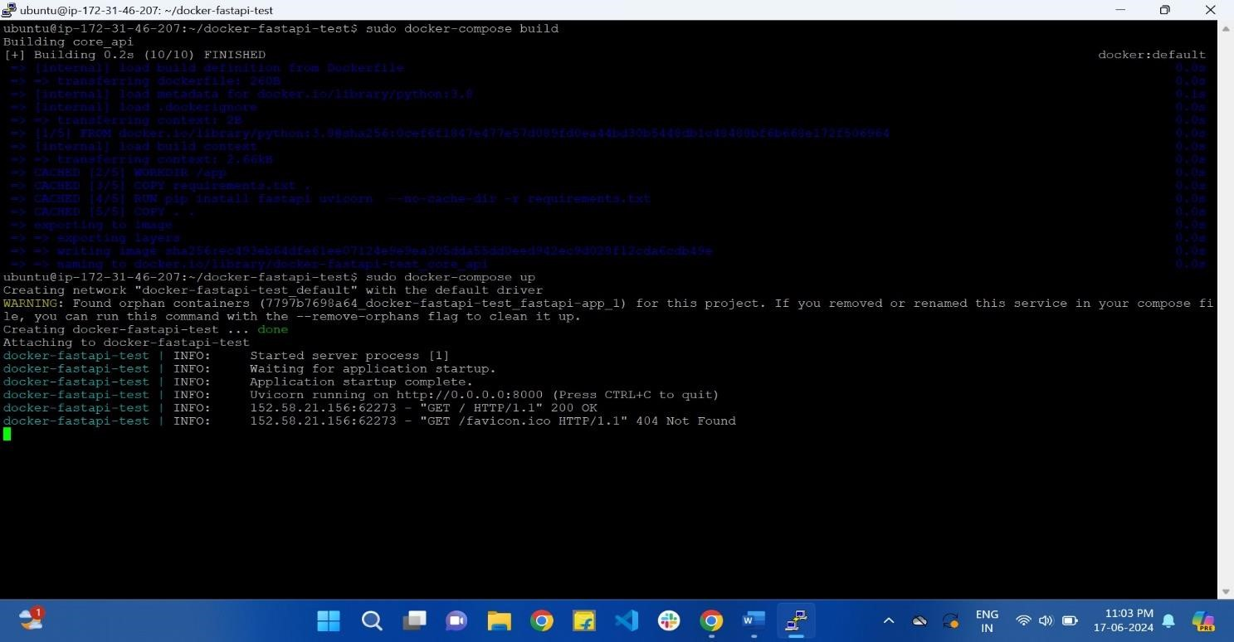

***Step4*:** Check the Containerized App Accessible on Web

IP 54.225.5.240:8000

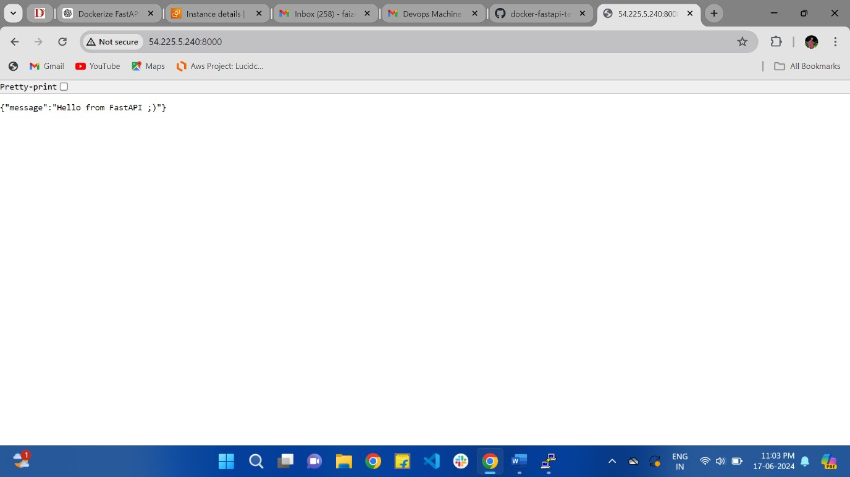

IP 54.225.5.240:8000/docs

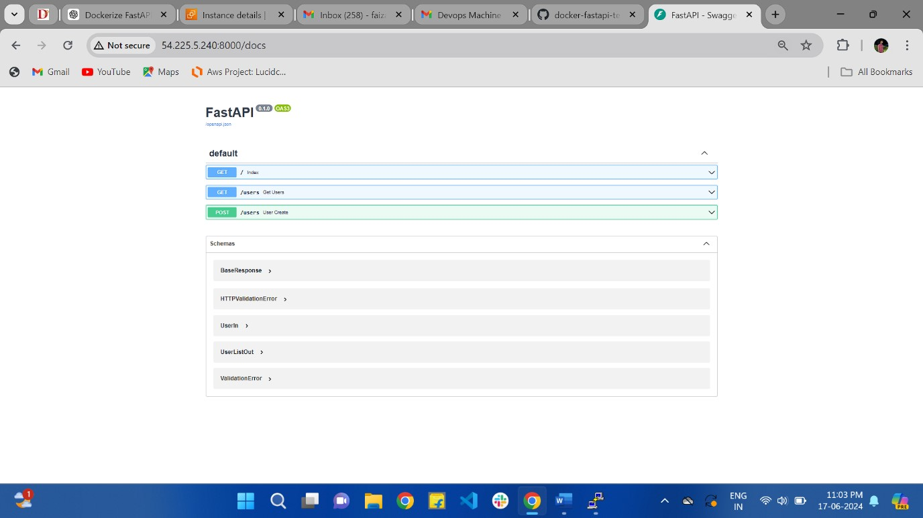

Accepts and stores user data in JSON file

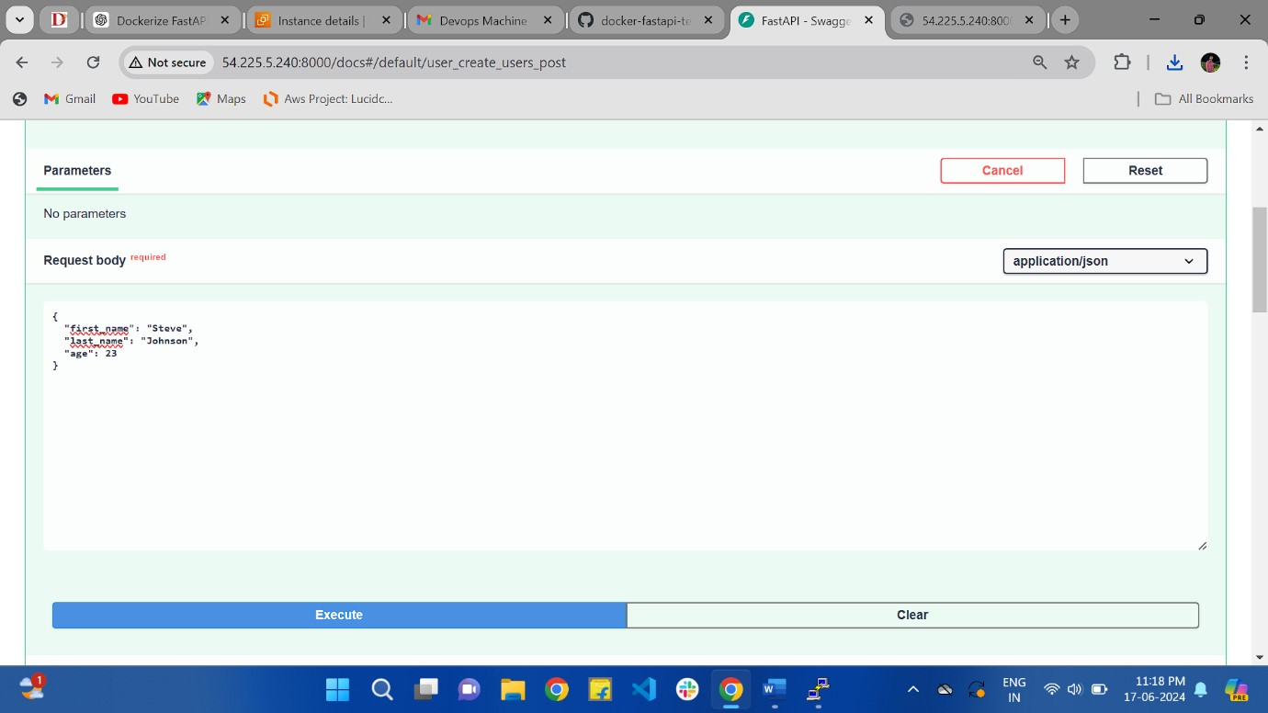

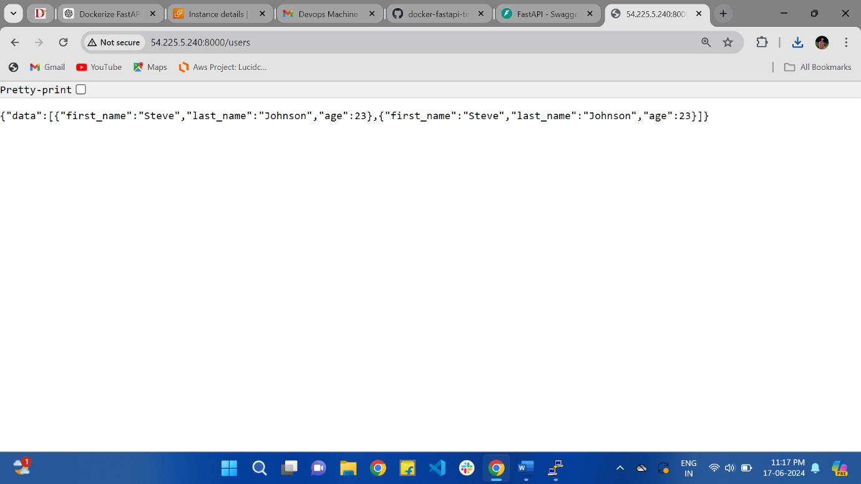

***Step5*:** Stop the Container and check Data Persistence

CMD: docker-compose down

***Step6*:** Check the data/users.json File: Ensure that the file contains the data previously added

Curl -X GET http:// 54.225.5.240:8000/users

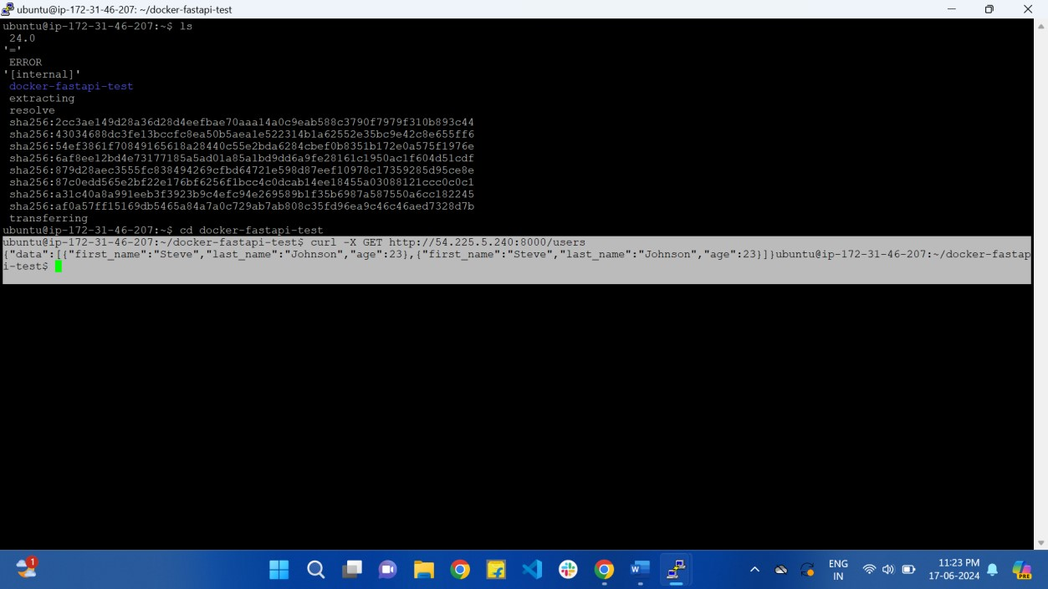

***Step7*:** Commit and push changes to your forked repo CMD: git add.

git commit -m “Fast-API app” git push origin main.

# ThankYou